# Data Communication and Network LAB

FAROOQ AHMAD Experiment # 2  
17L4407 Lab Report # 2  
BEE-5A

## INTRODUCTION TO NETWORK SIMULATOR VERSION-3 (NS-3)

## INTRODUCTION

In this lab session, we were introduced to the network simulator version 3. **ns-3** is a discrete-event network simulator for Internet systems, targeted primarily for research and educational use. ns-3 is free software, licensed under the GNU GPLv2 license, and is publicly available for research, development, and use. In ns-3 there is no concept of the operating system, the basic level of abstraction in ns-3 is the application level-user program. This abstraction is represented in C++ by the class named ‘Application’. This class provides methods for managing the representation of developer’s version of user-level application in simulations.

## OBJECTIVE

The course learning objective of this lab session was to introduce us to the Ubuntu 32 bit and network simulator version 3 all in one. Moreover to use the ns3 to build and analyze simple topology using point to point link.

## DESIGN PROCEDURE

Task required to perform  
1. Understand each and every line of the above code, run the above script and comment on the output. 2. Modify the code so that 4 packets are sent and echoed.   
3. Create 2 node with a single interface as shown in figure 2.1:   
4. Point to point link   
5. Data rate set to 8 Mbps, transmission delay set to 4ms   
6. IP set to 192.168.40.0   
7. Udp Echo Server Port set to 93   
8. Packet size set to 512 bytes

Solution   
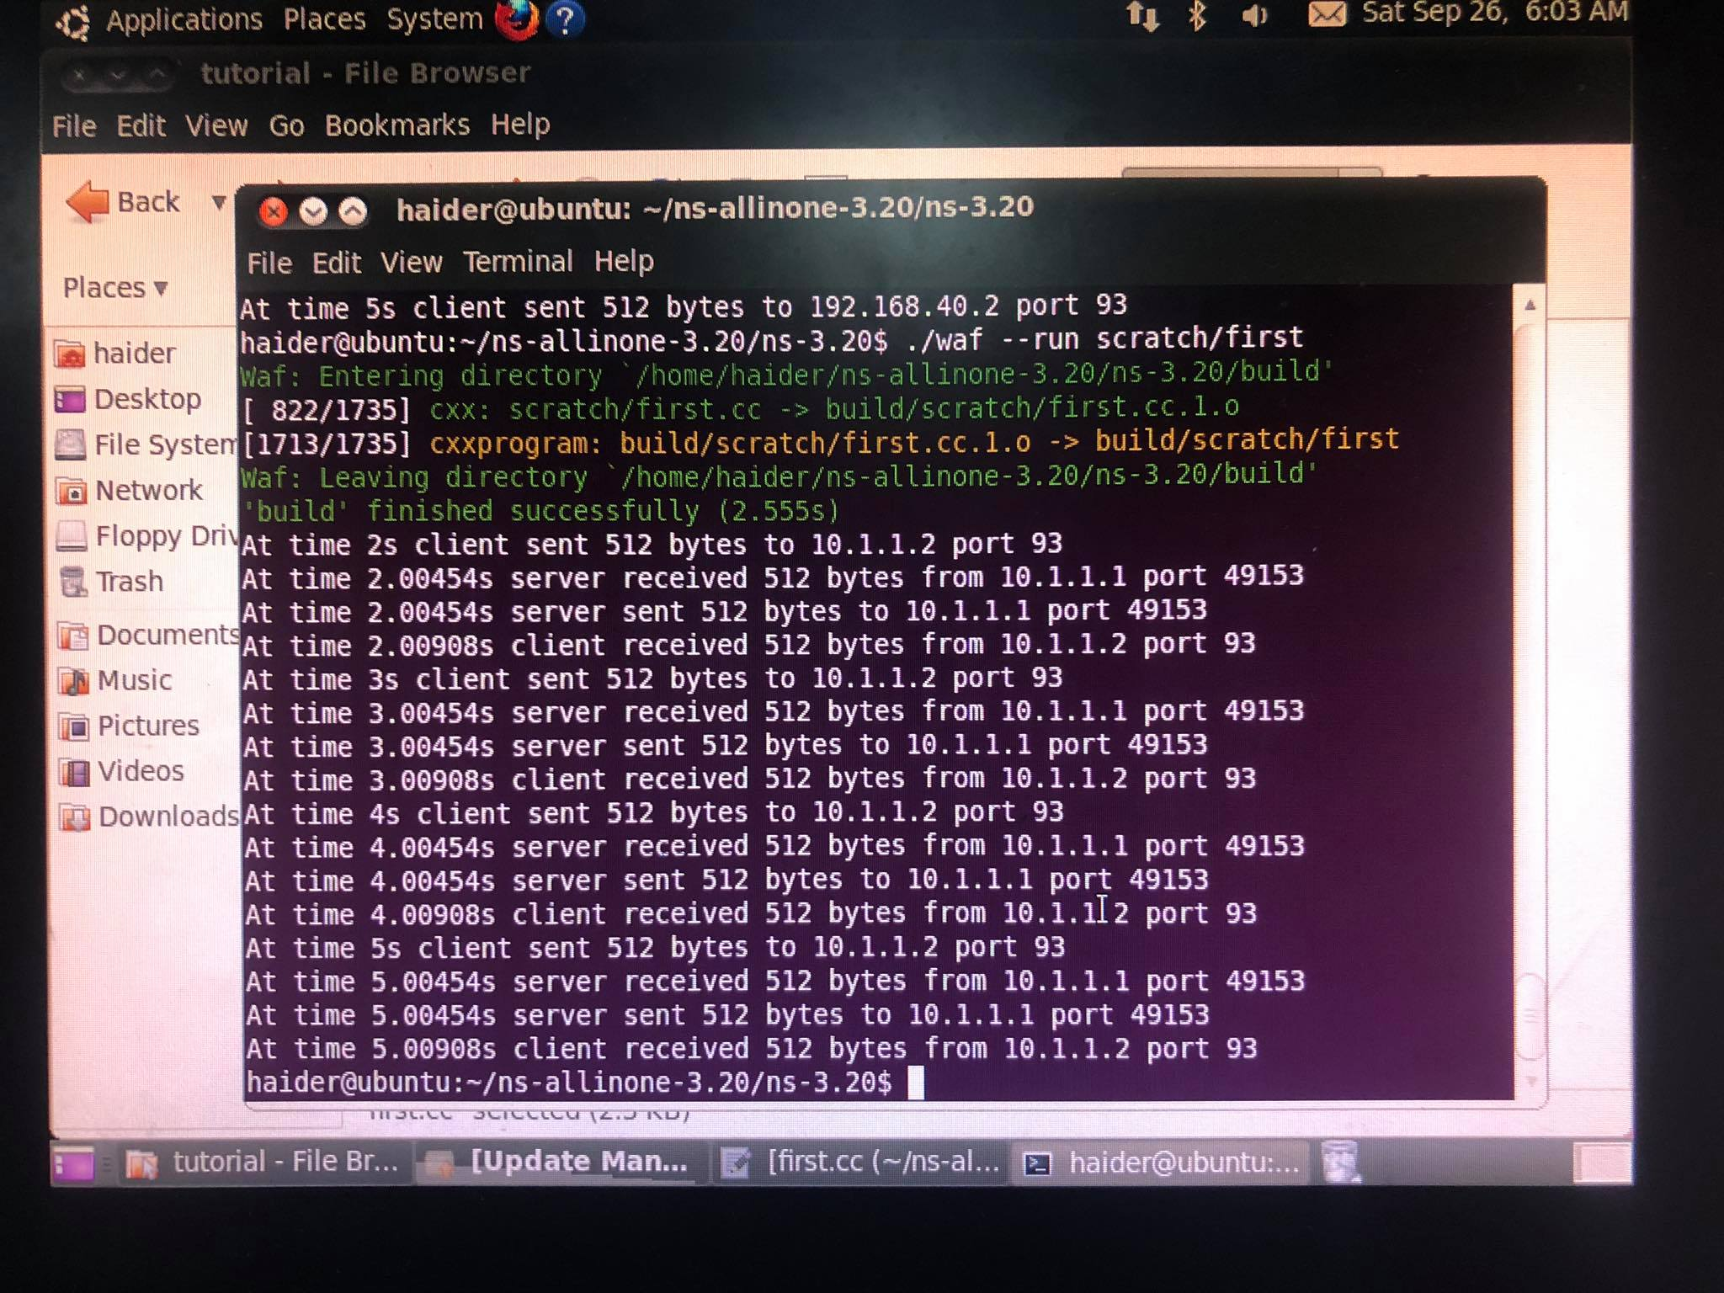  
packet sent and received successfully

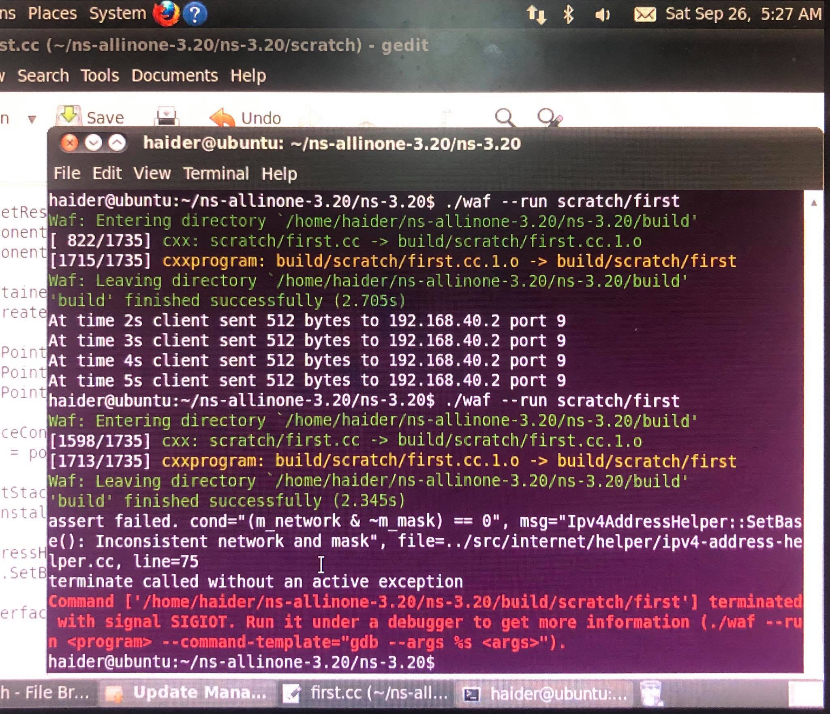

Packet missed.

## ISSUES

There were as such none issues.

## CONCLUSION

This lab session was conducted successfully. The concepts of network simulator 3 were understood and used to build and analyze a simple topology using point to point link. Moreover the theory behind VMware and Ubuntu was also understood and work was done on Ubuntu 32 bit ns3 on VMware.

## APPLICATIONS

NS3 helps to create various virtual nodes (i.e., computers in real life) and with the help of various Helper classes it allows us to install devices, internet stacks, application, etc to our nodes.

Using NS3 we can create PointToPoint, Wireless, CSMA, etc connections between nodes. PointToPoint connection is same as a LAN connected between two computers. Wireless connection is same as WiFi connection between various computers and routers.

## POST LAB

/* -*- Mode:C++; c-file-style:"gnu"; indent-tabs-mode:nil; -*- */

/*

* This program is free software; you can redistribute it and/or modify

* it under the terms of the GNU General Public License version 2 as

* published by the Free Software Foundation;

*

* This program is distributed in the hope that it will be useful,

* but WITHOUT ANY WARRANTY; without even the implied warranty of

* MERCHANTABILITY or FITNESS FOR A PARTICULAR PURPOSE. See the

* GNU General Public License for more details.

*

* You should have received a copy of the GNU General Public License

* along with this program; if not, write to the Free Software

* Foundation, Inc., 59 Temple Place, Suite 330, Boston, MA 02111-1307 USA

*/

#include "ns3/core-module.h"

#include "ns3/network-module.h"

#include "ns3/internet-module.h"

#include "ns3/point-to-point-module.h"

#include "ns3/applications-module.h"

using namespace ns3;

NS_LOG_COMPONENT_DEFINE ("FirstScriptExample");

int

main (int argc, char *argv[])

{

Time::SetResolution (Time::NS);

LogComponentEnable ("UdpEchoClientApplication", LOG_LEVEL_INFO);

LogComponentEnable ("UdpEchoServerApplication", LOG_LEVEL_INFO);

NodeContainer nodes;

nodes.Create (3);

PointToPointHelper pointToPoint1,pointToPoint2;

pointToPoint1.SetDeviceAttribute ("DataRate", StringValue ("8Mbps"));

pointToPoint1.SetChannelAttribute ("Delay", StringValue ("8ms"));

pointToPoint2.SetDeviceAttribute ("DataRate", StringValue ("8Mbps"));

pointToPoint2.SetChannelAttribute ("Delay", StringValue ("4ms"));

NetDeviceContainer devices1,devices2;

devices1 = pointToPoint1.Install (nodes.Get(0),nodes.Get(1));

devices2 = pointToPoint2.Install (nodes.Get(2),nodes.Get(1));

InternetStackHelper stack;

stack.Install (nodes);

Ipv4AddressHelper address1,address2,address3;

address1.SetBase ("192.168.1.0", "255.255.255.0");

address3.SetBase ("192.168.5.0", "255.255.255.0");

address2.SetBase ("192.168.40.0", "255.255.255.0");

Ipv4InterfaceContainer interfaces1 = address1.Assign (devices1);

Ipv4InterfaceContainer interfaces2 = address3.Assign (devices2);

Ipv4GlobalRoutingHelper :: PopulateRoutingTables();

UdpEchoServerHelper echoServer (9);

ApplicationContainer serverApps = echoServer.Install (nodes.Get (1));

serverApps.Start (Seconds (0.0));

serverApps.Stop (Seconds (15.0));

UdpEchoClientHelper echoClient (interfaces1.GetAddress (1), 9);

echoClient.SetAttribute ("MaxPackets", UintegerValue (6));

echoClient.SetAttribute ("Interval", TimeValue (Seconds (1.0)));

echoClient.SetAttribute ("PacketSize", UintegerValue (512));

ApplicationContainer clientApps = echoClient.Install (nodes.Get (0));

clientApps.Start (Seconds (0.0));

clientApps.Stop (Seconds (5.0));

UdpEchoClientHelper echoClient1 (interfaces2.GetAddress (1), 9);

echoClient1.SetAttribute ("MaxPackets", UintegerValue (6));

echoClient1.SetAttribute ("Interval", TimeValue (Seconds (1.0)));

echoClient1.SetAttribute ("PacketSize", UintegerValue (512));

ApplicationContainer clientApps = echoClient1.Install (nodes.Get (2));

clientApps.Start (Seconds (5.0));

clientApps.Stop (Seconds (15.0));

Simulator::Run ();

Simulator::Destroy ();

return 0;

}